Question 1 :-

1. Create a blank file named “myfile”

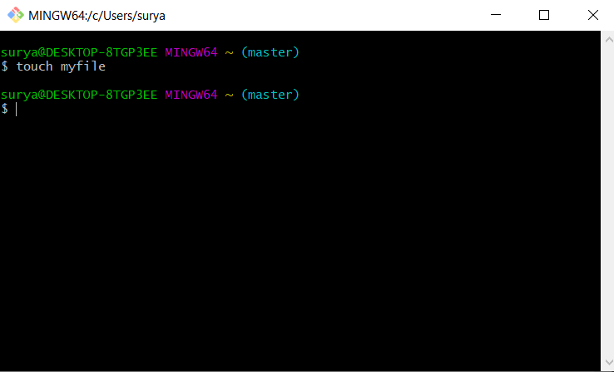

1. Open “myfile” in vi editor

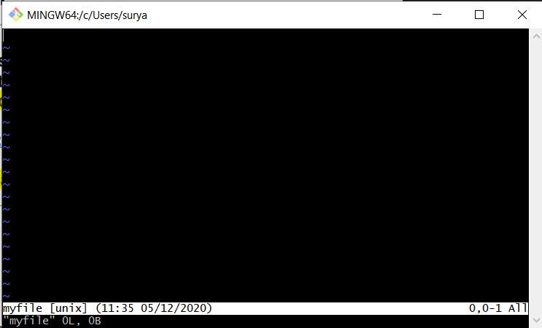

1. Write your name , address , email id , phone no and blood group in 5 different line

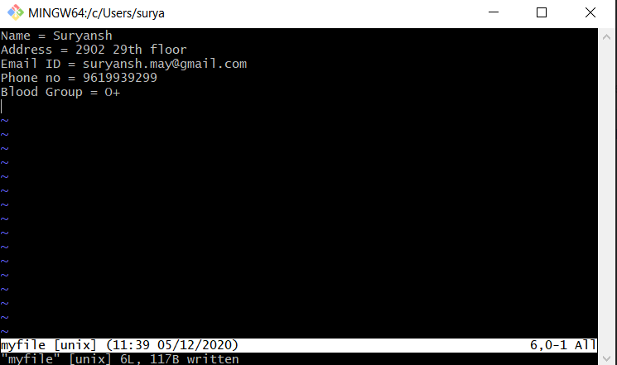

1. Build one Single expression to see the line with the name and blood group in myfile

